# **29. FIRST HOP REDUNDANCY PROTOCOLS (FHRPs)**

## **THE PURPOSE OF FHRPs**

**What happens when the configured DEFAULT GATEWAY for network HOSTS goes down?**

* Routed traffic becomes inaccessible.
* To route traffic to a functional gateway (e.g., R2 at .253), **First Hop Redundancy Protocol** is used.

**Solution:**FHRPs are designed to protect the **DEFAULT GATEWAY** by enabling **multiple routers** to back up the gateway address.

## **HOW FHRP WORKS**

1. **Two (or more) routers** share a **Virtual IP (VIP)**.
2. Hosts use the **VIP** as the **default gateway IP**.
3. Routers communicate using **“Hello” messages**:
   * One router becomes **Active**.
   * Others are in **Standby**.
4. **Host Traffic Workflow**:
   * A host sends traffic to an external address, using the **VIP** to find its MAC address.
   * The **Active Router** responds with the **Virtual MAC Address**, and traffic flows as:
     + **Source IP**: Host IP
     + **Destination IP**: External address
     + **Source MAC**: Host MAC
     + **Destination MAC**: Gateway MAC (VIP MAC)

### **Failover Process**

* If the **Active Router (e.g., R1)** goes down, the **Standby Router (e.g., R2)** becomes Active after missing “Hello” messages.
* The **Host ARP Table** remains unchanged since the **VIP MAC** stays consistent.
* **R2** updates switches with a **Gratuitous ARP**:
  + Broadcasts the ARP reply without an ARP request. Frames are broadcast to FFFF.FFFF.FFFF (normal ARP replies are unicast)

### **Recovery**

* When R1 comes back online:
  + It becomes **Standby**.
  + **R2** stays Active unless preemption is enabled.
* **Note**: FHRPs are **non-preemptive** by default. ( can change this setting)

## **FHRP VARIANTS**

### **1. HSRP (Hot Standby Router Protocol)**

* **Cisco proprietary**.
* Roles: **Active** and **Standby** routers.
* **Two versions**:
  + **v1**: IPv4, multicast address 224.0.0.2.
  + **v2**: Adds IPv6, multicast address 224.0.0.102.
* Virtual MAC Addresses:
  + **v1**: 0000.0c07.acXX (XX = Group number).
  + **v2**: 0000.0c9f.fXXX (XXX = Group number).

### **2. VRRP (Virtual Router Redundancy Protocol)**

* **Open standard**.
* Roles: **Master** and **Backup** routers.
* Multicast address: 224.0.0.18.
* Virtual MAC Address:
  + 0000.5e00.01XX (XX = Group number, in hex for numbers > 99).

### **3. GLBP (Gateway Load Balancing Protocol)**

* **Cisco proprietary**.
* Enables **load balancing** among multiple routers in a subnet.
* Roles:
  + **AVG (Active Virtual Gateway)**: Assigns up to 4 **AVFs (Active Virtual Forwarders)**.
* Multicast address: 224.0.0.102.
* Virtual MAC Address: 0007.b400.XXYY (XX = Group, YY = AVF).
* Each AVF acts as the default gateway for a portion of the hosts in the subnet

## **CONFIGURATION**

### **HSRP Basic Configuration Example (Good to know, not tested in CCNA)**

#### **R1 Configuration**

R1(config)# interface GigabitEthernet0/0

R1(config-if)# ip address 192.168.1.1 255.255.255.0

Alternatively: R1(config-if)# standby version 2

R1(config-if)# standby 1 ip 192.168.1.254

R1(config-if)# standby 1 priority 110

R1(config-if)# standby 1 preempt

R1(config-if)# standby 1 version 2

R1(config-if)# standby 1 timers 1 3

#### **R2 Configuration**

R2(config-if)# standby 1 interface GigabitEthernet0/0

R2(config-if)# standby 1 ip address 192.168.1.2 255.255.255.0

R2(config-if)# standby 1 ip 192.168.1.254

R2(config-if)# standby 1 priority 100

R2(config-if)# standby 1 version 2

* Active router is determined in this order 1) Highest priority(default 100) 2) Highest IP address
* Preempt cause the router to take the role of active router even if another router already has the role
* Preempt only needed to configure on the router you want to be active

HSRP version and group number must match between router to work

### **HSRP Key Notes**

* **Group numbers** must match across routers in the subnet.
* HSRP versions must be consistent.
* Use the show standby command to verify configurations.

## 

## 

## 

## 

## 

## **MEMORIZE THIS CHART**

Refer to the visual chart to understand differences between HSRPs.

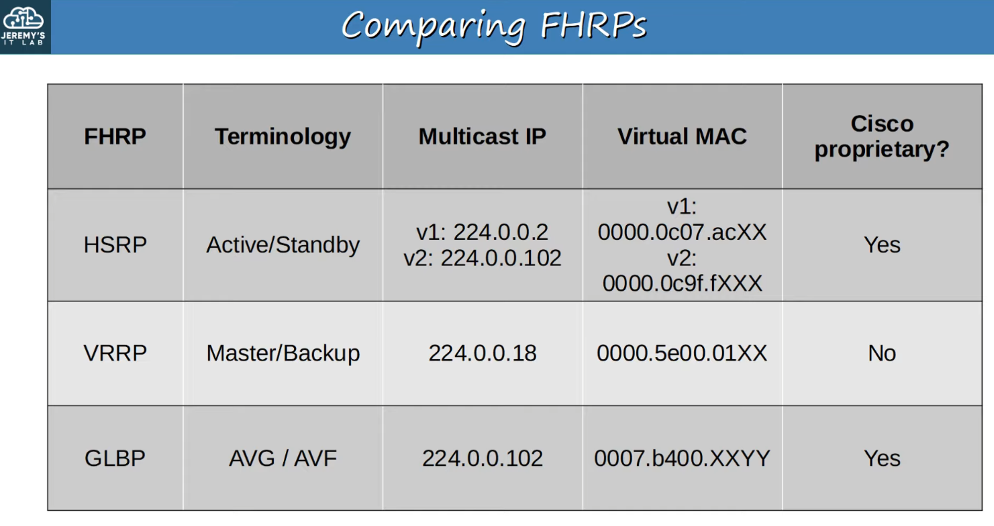

#subnets divide the network in layer 3 while VLANS divide the network in layer 2, they work together